Effect of Increased Precipitation (Heavy Rain Events) on Minnesota Pavement Foundations

Interim Report for Task 4: Development of a GIS Map of the MnDOT Road Network Showing Foundation Vulnerability during Heavy Precipitation

Submission Date:

August 15, 2023

**Project Team:**

**Principal Investigator**

Halil Ceylan, Pitt-Des Moines, Inc. Endowed Professor, Civil, Construction, and Environmental Engineering (CCEE)

Director, Program for Sustainable Pavement Engineering and Research (PROSPER)

Institute for Transportation (InTrans), Iowa State University

**Co-Principal Investigator**

Sunghwan Kim, Research Scientist, CCEE, Iowa State University

**Research Assistant**

Md Jibon, CCEE, Iowa State University

**Postdoctoral Research Associate**

Md Abdullah All Sourav, CCEE, Iowa State University

**Table of Contents**

Task 4: Development of a GIS Map of the MnDOT Road Network Showing Foundation Vulnerability during Heavy Precipitation 4

1. Introduction 4

2. Task 4 Objectives 4

3. PLAXIS 3D Hydraulic Modeling 5

(i) Representative Pavement Model 5

(ii) Available Statewide Aggregates Information 6

(iii) Hydraulic Conductivity and SWCC properties of Aggregates 7

4. Developing Prediction Model for Foundation Stiffness 8

5. Developing Vulnerability Map for Minnesota 8

6. Summary and Recommendations 8

References 9

**List of Figures**

Figure 1. Example of PLAXIS 3D model with the dimensions of each layer 5

**List of Tables**

Table 1. List of material properties for example pavement model (Cetin et al. 2021 and Pease 2010) 5

Table 2. List of base aggregates and their classification (Cetin et al. 2021 and Oh et al. 2021) 6

Table 3. Saturated volumetric water content, pressures at the air-entry level, and van Genuchten Model Parameters (Cetin et al. 2021 and Oh et al. 2021) 7

# Task 4: Development of a GIS Map of the MnDOT Road Network Showing Foundation Vulnerability during Heavy Precipitation

## Introduction

In Task 3, mechanistic-based regression models for three different types of aggregates were developed to predict stiffness of base layer based on hydraulic conductivity, rainfall intensity and duration. These equations will be updated in Task 4 to represents statewide different types of aggregate used in pavement systems. The revised mechanistic-based prediction models will be employed to create a GIS-based pavement foundation vulnerability map for a selected site representing Minnesota's pavement systems. Esri's ArcGIS Pro, a leading mapping and spatial analytics software widely used by GIS experts, will be utilized for this purpose. ArcPy, a library developed by Esri, will serve as the backbone for automation and scripting, leveraging the integrated Python 3.X version of ArcGIS Pro, which includes several pre-installed libraries such as NumPy, pandas, Matplotlib, Seaborn, and TensorFlow. Additional standard libraries can also be installed as needed. The GIS map development process for this task encompasses four major steps: data collection, data processing, modeling, and output mapping. MnDOT weather station data from the selected site will be automatically collected using web scraping and saved locally. Generic Python data analysis libraries like NumPy, pandas, and SciPy will be utilized to process and organize the collected data into a tabular format. The mechanistic-based prediction models will be implemented using Python and integrated into ArcGIS Pro. Tabularized data will serve as inputs for generating the GIS map, which will visualize the changes in resilient modulus of the pavement foundation soil due to moisture variations caused by heavy precipitation. Furthermore, this project will demonstrate automatic periodic updates of resilient modulus values using the most recent weather station data. It will also showcases the ability to update site maps when new data becomes available on the source website. Similarly, the outcomes of this project will exhibit mapping functionality and periodically update resilience resistance values in response to heavy precipitations.

## Task 4 Objectives

The objectives of Task 4 of this study include:

1. Update the mechanistic-based prediction models to incorporate the statewide different types of aggregate
2. Create a GIS-based pavement foundation vulnerability map for a selected site representing Minnesota's pavement systems

## PLAXIS 3D Hydraulic Modeling

The primary objective of utilizing PLAXIS 3D modeling is to estimate the degree of saturation within the base aggregate layer in response to heavy rainfall. In order to achieve this, the PLAXIS 3D modeling will incorporate various types of statewide aggregates to create a comprehensive database of base layer saturation. This database of saturation values in the base layer will serve as a foundation for the development of a prediction model. The prediction model will utilize the available information to forecast the degree of saturation in the base aggregate layer based on specific conditions such as rainfall intensity, duration, and other relevant factors.

### Representative Pavement Model

A pavement structure was created in PLAXIS 3D to represent the Cell188 of MnROAD low volume road. **Figure 1** provides the dimensions of each pavement layer that was created in the PLAXIS 3D model. To assess the impact of rainfall on the pavement structure, a rainfall simulation was carried out within this model. The output from the PLAXIS 3D simulation provided estimates of the saturation levels within the base aggregate layer. To validate these saturation levels, the model-generated data was compared to field moisture sensor data.

In the subsequent steps of the analysis, the base layers of the pavement structure will be replaced with statewide representative aggregates. Rainfall simulations will then be conducted to observe and capture the response of these different base aggregates to rainfall events. By performing these steps, the study aims to gain insights into how different base aggregates respond to rainfall, which can provide valuable information for pavement design and maintenance considerations.

Figure 1. Example of PLAXIS 3D model with the dimensions of each layers

The key material properties for PLAXIS 3D hydraulic modeling dealing with unsaturated soil behavior are the parameters related to soil water characteristic curves and saturated hydraulic conductivity of the materials. The input material properties for the representative PLAXIS 3D model are listed in **Table 1**.

Table 1. List of material properties for example pavement model (Cetin et al. 2021 and Pease 2010)

|  |  |  |  |  |  |  |
| --- | --- | --- | --- | --- | --- | --- |
| Parameter | Symbol | Asphalt Concrete | Limestone Aggregate | Select Granular | Clay  Loam | Unit |
| General | | | | | | |
| Soil model |  | Linear elastic | Linear elastic | Linear elastic | Linear elastic |  |
| Drainage type |  | Undrained | Undrained | Undrained | Undrained |  |
| Unsaturated unit weight |  | 145 | 127 | 120 | 115 | lb/ft3 |
| Saturated unit weight |  | 152 | 145 | 135 | 125 | lb/ft3 |
| Initial void |  | 0.07 | 0.25 | 0.40 | 0.32 |  |
| Mechanical | | | | | | |
| Stiffness |  | 200 | 29.0 | 21.8 | 10.0 | ksi |
| Poisson’s ratio |  | 0.3 | 0.35 | 0.35 | 0.35 |  |
| Groundwater | | | | | | |
| van Genuchten model parameters |  | 0.01 | 0.089 | 0.028 | 0.13 |  |
|  | 1.0 | 1.0 | 1.0 | 1.0 |  |
|  | 8.320 | 3.50 | 1.93 | 2.8 |  |
|  | 1.677 | 2.64 | 4.52 | 3.82 |  |
|  | 0.5 | .25 | -0.36 | 1.2 |  |
| Hydraulic conductivity |  | 0.002 | 0.919 | 4.10 | 0.26 | in/hr |
|  | 0.002 | 0.919 | 4.10 | 0.26 | in/hr |
|  | 0.002 | 0.919 | 4.10 | 0.26 | in/hr |

### Available Statewide Aggregates Information

Oh et al. (2021) conducted extensive study to investigate the drainage quality of base aggregates. A collection of coarse-grained samples was obtained from stakeholders of the NRRA (National Road Research Alliance) to encompass a variety of materials utilized or considered for use in transportation infrastructure systems. The materials consisted of 17 distinct samples, including poorly graded sand (SP), silty sand (SM), well-graded sand (SW), poorly graded gravel (GP), silty gravel (GM), and well-graded gravel (GW). The selection of materials was a collaborative effort between NRRA representatives and the Departments of Transportation of Minnesota (MnDOT), Missouri (MnDOT), and Wisconsin (WisDOT). This study only includes aggregates used in state of Minnesota during base layer construction. Also, Cetin et al. (2021) also conducted extensive laboratory investigation for monitoring the performances of base aggregates from MnROAD facility. **Table 2** shows the commonly used aggregates for base layer construction in Minnesota.

Table 2. List of base aggregates and their classification (Cetin et al. 2021 and Oh et al. 2021)

|  |  |  |
| --- | --- | --- |
| Material ID | Name | USCS Classification |
| #1 | Limestone | GM |
| #2 | MN Class 6 | SP-SM |
| #3 | RCA+RAP | SP-SM |
| #4 | MN Class 5 | SW-SM |
| #5 | Bryan Redrock Class 5, MnDOT Pit 70006 | GM |
| #6 | Bryan Redrock Ball Diamond material, MnDOT Pit 70006 | SM |
| #7 | MN Class 5Q | GW |

### Hydraulic Conductivity and SWCC properties of Aggregates

The saturated hydraulic conductivity values (Ksat) were determined for the samples by compacting them in a rigid-walled permeameter and employing the constant head method as outlined in ASTM D2434 (Oh et al. 2021 and Cetin et al. 2021). Soil water characteristic curves (SWCCs) for the materials were determined using a hanging column test apparatus, following the guidelines outlined in ASTM D6836. The apparatus consists of a large-diameter cell containing the compacted specimen, a graduated outflow tube for measuring the effluent water, and two reservoirs with a manometer for applying suction pressure. The diameter of the specimen within the cell was 30.6 cm, while the height of the specimen varied between 3.0 cm and 5.0 cm, depending on the grain size, to maintain a representative grain size distribution. Both hydraulic conductivity and SWCC parameters are the key material properties for the hydraulic modeling in PLAXIS 3D. Table 3 lists the hydraulic properties of base aggregate that includes both hydraulic conductivity and SWCC parameters.

Table 3. Saturated volumetric water content, pressures at the air-entry level, and van Genuchten Model Parameters (Cetin et al. 2021 and Oh et al. 2021)

|  |  |  |  |  |  |  |  |  |  |
| --- | --- | --- | --- | --- | --- | --- | --- | --- | --- |
| Materials ID | Saturated Hydraulic Conductivity, ksat | | Air-entry Pressure | | van Genuchten Model Parameters | | | | |
| cm/s | in/hr | kPa | psi |  |  |  |  |  |
| #1 | 0.0006 | 0.919 | 1.75 | 0.25 | 0.02 | 0.25 | 3.50 | 2.64 | 0.25 |
| #2 | 0.005 | 7.39 | 0.30 | 0.04 | 0.07 | 0.33 | 3.75 | 2.88 | 1.20 |
| #3 | 0.0005 | 0.738 | 1.40 | 0.20 | 0.012 | 0.299 | 4.50 | 2.80 | 0.15 |
| #4 | 0.003 | 4.25 | 2.90 | 0.42 | 0.07 | 0.24 | 3.16 | 1.46 | 0.50 |
| #5 | 0.016 | 22.68 | 2.10 | 0.30 | 0.00 | 0.28 | 1.20 | 6.0 | 0.50 |
| #6 | 0.0004 | 0.567 | 2.60 | 0.38 | 0.08 | 0.32 | 1.65 | 2.54 | 0.50 |
| #7 | 0.0005 | 0.738 | 0.10 | 0.01 | 0.05 | 0.34 | 1.38 | 3.62 | 0.50 |

## Developing Prediction Model for Foundation Stiffness

Multiple rainfall scenarios will be generated, and the resulting moisture fluxes within the base aggregate layers will be computed using PLAXIS 3D. For the PLAXIS 3D simulations, the lower and upper limits for rainfall intensity will be set at 1 in/hr and 8 in/hr, respectively. The maximum duration for rainfall will be set at 12 hours. These specific rainfall intensity and duration values were chosen based on the historical rainfall data from the MnROAD facility spanning the past 25 years. Once the saturation values within the middle of the base layer have been determined, a prediction model will be developed to forecast saturation levels based on the rainfall intensity, duration, and hydraulic conductivity. Subsequently, the resilient modulus of the aggregates will be calculated for each saturation value using the MEPDG equation (Zapata et al. 2007, Witczak et al. 2000). The final prediction model will provide resilient modulus of base layer based on the hydraulic conductivity of the materials, rainfall intensity and duration.

## Developing Vulnerability Map for Minnesota

The relevant spatial data will be collected that are related to foundation vulnerability assessment, that include hydraulic conductivity of aggregates, rainfall intensity and duration. ArcGIS mapping capabilities will be utilized to create visual representations of the foundation vulnerability using graduated symbols, color ramps, or thematic maps to effectively communicate the vulnerability information.

(1)

A script was developed using open source programming language Python for saturation and MR calculation. The working principle of the script is shown below –

Weather data from LTPP

Saturation calculation

MR calculation

Shapefile creation

User inputs to CSV file

The weather data of MnRoad has been collect from LTPP website before hand. The data were compiled in MS Access with information related to precipitation, rainfall, snowfall, and so on. Only the information regarding the precipitation and rainfall were exported to csv file for further use. The user has to provide a number of information to run the algorithm. They are

* Location – latitude and longitude of the location
* Cell number or Identifier – Cell number for MnROAD facility cells or name or number of any place. As shown in chapter 4, the saturation calculation equation is different for cell 127, 188, and 189. Based on the cell number, the saturation calculation function is executed.
* Date – For which date the vulnerability map will be generated. The input format is day-MON-year. For example, 02-FEB-2018 or 10-JUL-2010.
* SOPT – Optimum saturation value
* MROPT – Optimum MR value
* Hydrlic _conduc – Hydralic conductivity

The program reads the user inputs and only extract the rainfall duration and intensity from the weather data. The rainfall intensity is calculated by dividing total rainfall amount by number of hours in rained. Hydraulic conductivity, rainfall duration, and rainfall intensity are used for

Where, RI (rainfall intensity in/hr) and rainfall duration (RD in hr) will come from weather data.

Hydraulic conductivity ( in/hr), HC will be the user input

For coarse-grained soils, parameter values *a* =-0.3123, *b* = 0.3, and *km* = 6.8157 are recommended (Zapata et al. 2007, Witczak et al. 2000).

In this equation, saturation (s) will come from previous equation (1) and we need to ask users for the MROPT value. The GIS map will show MR output.

MnROAD low volume road facility, 2.5-mile Low Volume Road (LVR)

(9011 77th St NE, Otsego, MN 55362)

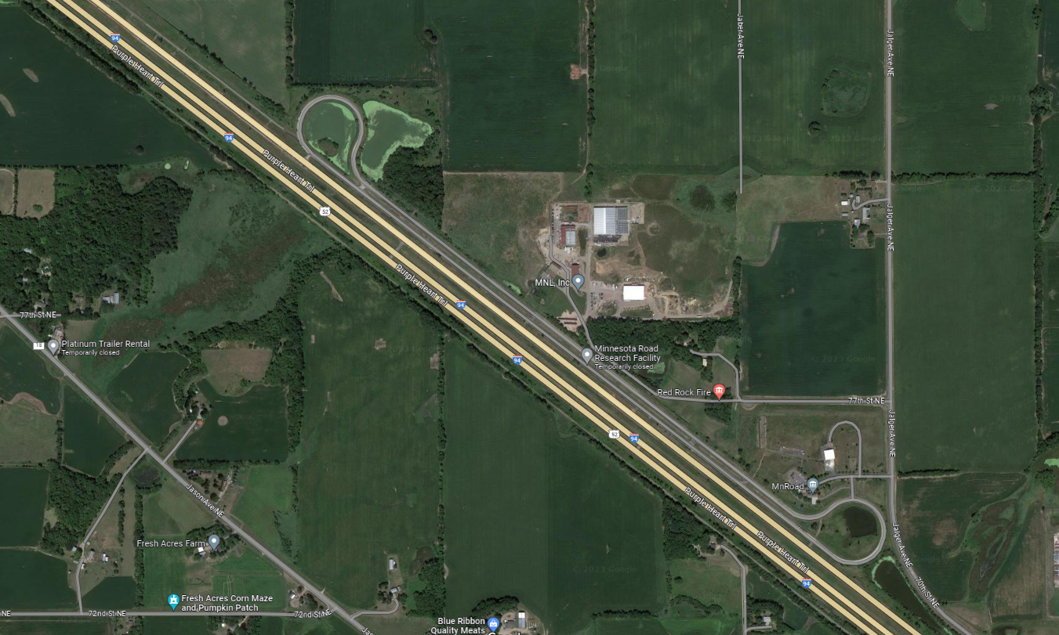

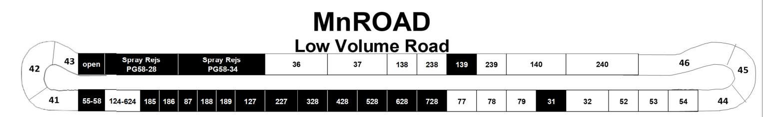

Cell 188, 189 and 127 are the three cells that we studied, additional 328 cell

GAP: 87-188 (2 ft), 188-189 (50 ft), 189-127(no gap), 127-227 (51 ft)

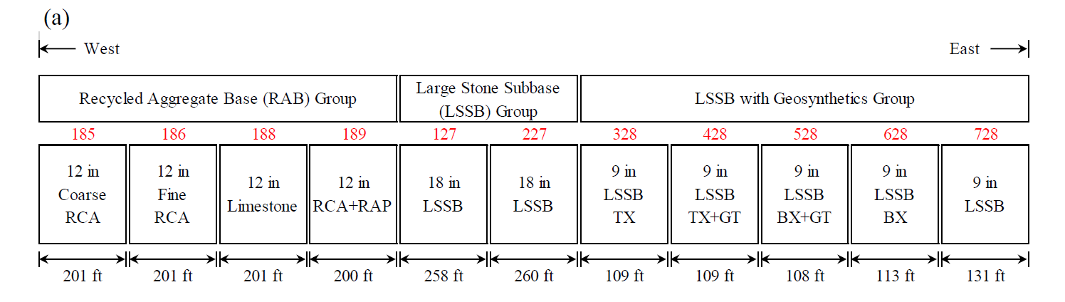

## Summary and Recommendations

## References

Cetin, B., Coban, H. S., Edil, T. B., Ceylan, H., Likos, W. J., Zheng, J., and Buss, A. (2021). Determining Pavement Design Criteria for Recycled Aggregate Base and Large Stone Subbase (No. NRRA202103). Minnesota. Dept. of Transportation. Office of Policy Analysis, Research & Innovation.

Oh, H., Likos, W. J., & Edil, T. B. (2021). Drainability of Base Aggregate and Sand (No. NRRA202107). Minnesota. Department of Transportation.

Witczak, M.W., Andrei, D., and Houston, W. N. (2000). Resilient Modulus as Function of Soil Moisture – Summary of Predictive Models. Development of the 2002 Guide for the Development of New and Rehabilitated Pavement Structures, NCHRP 1-37 A, Inter Team Technical Report (Seasonal 1). Arizona State University, Tempe, Arizona.

Zapata, C.E., Andrei, D., Witczak, M.W., and Houston, W.N. (2007). Incorporation of environmental effects in pavement design. Road Materials and Pavement Design, 8(4), 667-693. https://doi.org/10.3166/rmpd.8.667-693.